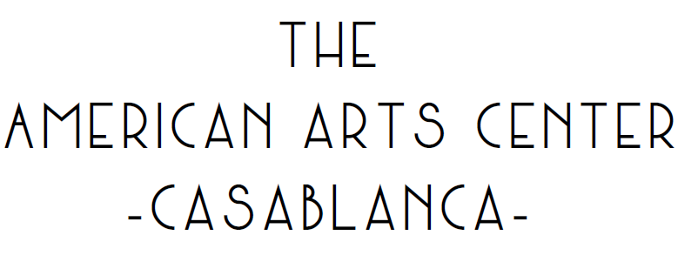
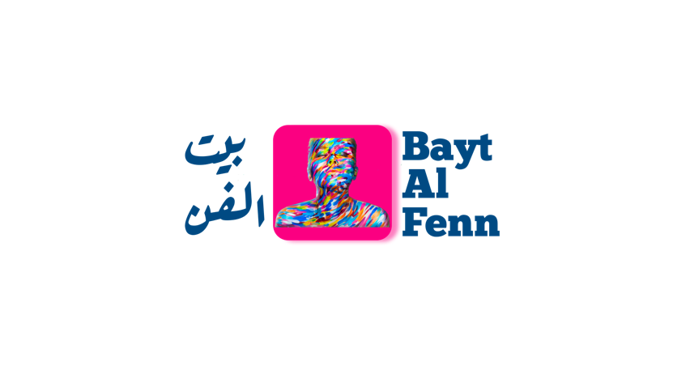
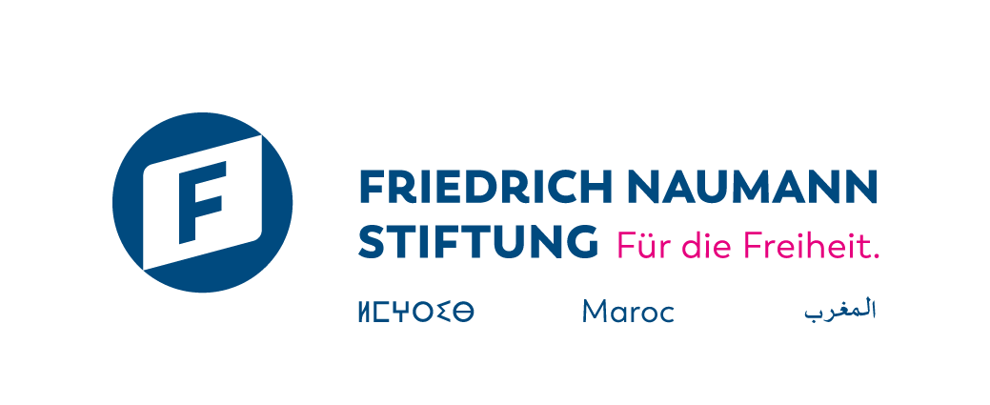

Call for Applications
Résidence Bayt Al Fenn 2024
9 Day Art Residency – Du 18 September au 27 September 2024.

DEADLINE FOR APPLICATIONS: 15 August 2024.
NOTE OF INTENT / VIDEO

Section 1 - Information relating to the Artist

 | PERSON 1 | PERSON 2 | PERSON 3
Name/ duo/collective
Last name(s) and first name(s)
Phone N°
City
Email Adress
Date of Birth
Nationality
CIN number / Residence permit

Section 2 - Project information
2.1 Information about the project

Project Name
Artistic discipline (visual arts, performing arts, audio-visual arts, dance, music, etc.)

2.2 Participating interest

- How did you hear about Bayt Al Fenn?

- Why do you want to take part in the Bayt Al Fenn - Hiya or Houwa residency (In 300 words maximum)

- What are your expectations of this residency? What do you hope to gain and learn from it? (In 300 words maximum)

Section 3 – Termes et conditions

To achieve their work, residents will have access to the following facilities:
- Full-board accommodation in a double room.
- Several creative spaces.
- The logistical support needed to produce the artwork (workspace, tools, installation)
- Visibilitý on all of Bayt Al Fenn's communication media as well as those of its partners.
In return, the resident artist agrees to:
- Spend the entire period of the project at the residency. If the artist leaves the site, the contract will automatically be terminated. For this reason, it is essential to check that the artist is available for 9 days.
- Authorize Bayt Al Fenn and, by extension, the (FFN Maroc) Friedrich Naumann Foundation for Freedom - Morocco and the American Arts Center to broadcast the images and statements in all media and/or communication channels free of charge.
- Design and produce an original individual artwork related to the residency's theme.
- Actively collaborate in the creation of a collective work synthesized during the residency.
- To attend the exhibition of his work on 14 November in Casablanca.
- Provide high-resolution visuals for communication medias.
If selected to take part in the Bayt Al Fenn residency, the artist agrees to:
- Take part in all the programme events from 18 September to 27 September.
- Participate actively and share all information concerning The progress of the artwork creation
For further information, please contact: baytalfenn@gmail.com

