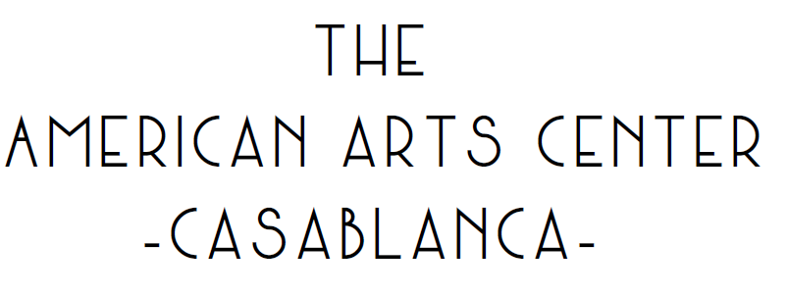
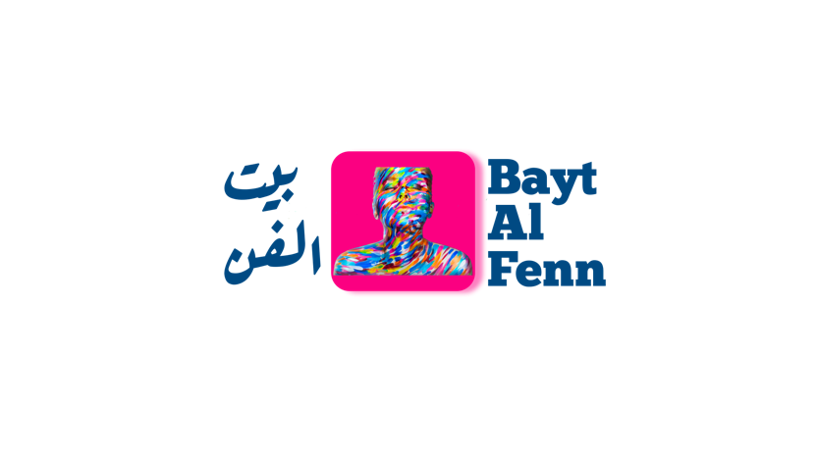
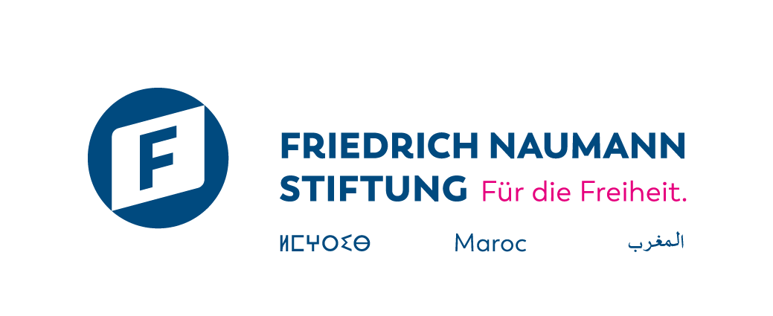

Call for Applications
Bayt Al Fenn 2025
8 Day Art Residency – Du September 19th To September 26th 2025.

DEADLINE FOR APPLICATIONS: 30th June 2025.
NOTE OF INTENT / VIDEO

Section 1 - Information relating to the Artist

 | PERSON 1 | PERSON 2 | PERSON 3
Name/ duo/collective
Last name(s) and first name(s)
Phone N°
City
Email Adress
Date of Birth
Nationality
CIN number / Residence permit

Section 2 - Project information
2.1 Information about the project

Project Name
Artistic discipline (visual arts, performing arts, audio-visual arts, dance, music, etc.)

2.2 Participating interest

- What is your artistic practice (visual arts, performing arts, other – please specify)?
- How long have you been practicing your discipline?
- Can you briefly describe your artistic approach? (150 words max)
- Have you participated in residencies or similar projects before? If yes, which ones?
- How did you hear about Bayt Al Fenn?
- How does this theme resonate with your artistic practice?
- Why do you wish to participate in the Bayt Al Fenn residency – Invisible Borders? (300 words max)
- What are your expectations for this residency? What skills and knowledge do you hope to gain? (300 words max)

Section 3 – Termes et conditions

To carry out their work, the resident will have the following resources:
- Online training to deepen their research project.
- Accommodation in a double room, full board.
- A creation workspace.
- The necessary logistical support for the production of the artwork (materials within budget and availability constraints).
- The exhibition of their work at the American Arts Center gallery.
- Visibility across all Bayt Al Fenn communication channels, as well as those of its partners.
In return, the artist-in-residence agrees to:
- Actively attend online meetings and trainings with coaches.
- Stay at the residency location for the entire duration of the project. If the artist leaves the residency, it will automatically terminate their contract. Therefore, it is essential to confirm their availability for the full 8 days.
- Design and create an original individual artwork related to the residency’s theme.
- Authorize Bayt Al Fenn and, by extension, the Friedrich Naumann Foundation for Freedom – Morocco (FFN Maroc) and the American Arts Center to use their images and statements across all media and/or communication channels free of charge.
- Actively collaborate in the creation of a collective artwork summarizing the residency.
- Attend the exhibition on November 20 in Casablanca.
- Provide high-resolution visuals for communication materials.

- If selected to participate in the Bayt Al Fenn residency, the artist commits to:
- Actively participate in various online events organized prior to the residency.
- Fully engage in all program events from September 18 to September 26.
- Actively participate and transparently share all information related to their progress.

