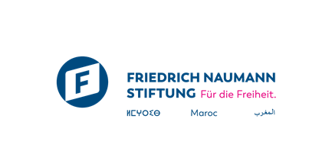
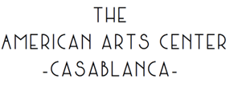

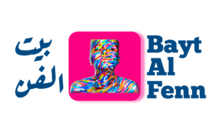

Call for Applications
Bayt Al Fenn 2026
9 Day Art Residency – September 16 to September 25 2026.

DEADLINE FOR APPLICATIONS: 20 July 2026.
NOTE OF INTENT / VIDEO

Section 1 - Information relating to the Artist

 | PERSON 1 | PERSON 2
Name/ duo/collective
Last name(s) and first name(s)
Phone N°
City
Email Adress
Date of Birth
Nationality
CIN number / Residence permit

Section 2 - Project information
2.1 Participating interest

- What is your artistic practice (visual arts, performing arts, other – please specify)?

- How long have you been practicing your discipline?

- Could you briefly describe your artistic approach? (150 words max)?

- Have you ever participated in residencies or similar projects? If so, which ones?

- How did you hear about Bayt Al Fenn?

- How does this theme resonate with your artistic practice?

- Why do you wish to participate in the Bayt Al Fenn residency? (300 words maximum)

- What contradiction, tension, or paradox do you perceive in the current transformations of Moroccan cities, and why does this interest you as an artist?

- What are your expectations regarding this residency? What strengths and learnings

- do you hope to acquire? (300 words maximum)

2.2 Information about the project

Project Name
Artistic discipline (visual arts, performing arts, audio-visual arts, dance, music, etc.)

1 Section 3 – Termes et conditions

To carry out their work, the resident will have the following resources:
• Online training to deepen their research project.
• Accommodation in a shared double room with full board.
• The necessary logistical support for the production of the artwork (materials provided within budget limit and availability).
• The exhibition of their work at the American Arts Center gallery.
• Visibility across all Bayt Al Fenn communication channels, as well as those of its partners.
In return, the artist-in-residence agrees to:
• Actively attend feedback and alignment meetings with coaches.
• Staying for the entire duration of the project at the residency location; if the artist leaves the residency, it will automatically terminate their contract. Therefore, it is crucial to confirm full availability for the 8 days.
• Designing and producing an original, unprecedented individual artwork related to the residency theme.
• Authorizing Bayt Al Fenn, and by extension the Friedrich Naumann Foundation for Freedom – Morocco (FNF Morocco) and the American Arts Center, to use their images and statements on all media and communication channels free of charge.
• Actively collaborating on the creation of a collective artwork that synthesizes the residency.
• Attend the exhibition on November 12th in Casablanca.
• Provide high-resolution visuals for communication materials.
If selected to participate in the Bayt Al Fenn residency, the artist commits to:

• Actively participating in various online events organized prior to the residency
• Participating in all program events in their entirety from September 16th to September 25th.
• Actively participating in various online events organized prior to the residency
• Actively participating and transparently sharing all information regarding their progress.
For any additional information, please contact us at: baytalfenn@gmail.com

